# INFOIBV 2023, Assignment1

Muhammed Budak (2154676)   
Süleyman Taşkın (8460051)

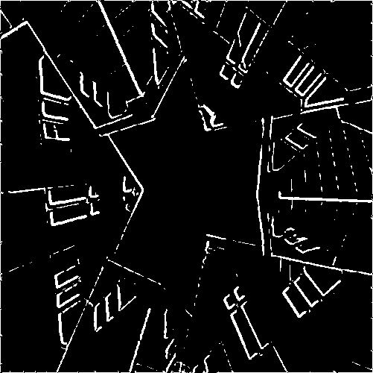

Image A (Converted to grey- Image B (5x5 gaussian filtered, Image C (5x5 median filtered,

scale and, contrast adjusted edge detected and, 100 edge detected and, 100.

loaded coloured image) as threshold applied image) as threshold applied image)

**Q1. Comparison of Images B and C. Why do we see these differences?**

For this assessment We use Image A as our base. Image A has been grayscaled and contrast adjusted. The images at the start of the documentation will be used as reference.   
**Image B:** 5x5 gaussian filtered, edge detected and 100 as threshold applied image.

**Image C:** 5x5 median filtered, edge detected and 100 as threshold applied image.

Before we compare the 2 images lets talk about the different filters and what the are used for.   
Let’s start with edge detection filter and threshold because both images use these at the end of the process. After that we will explain gaussian filter and median filter.

**Edge detection**

This filter is used to define edges and boundaries of an image. simply to say, sharp changes in the image brightness. These points where the image brightness varies sharply are called the edges (or boundaries) of the image.

Edge detection seeks to capture the structural information of objects within an image, playing a crucial role in various image analysis and computer vision tasks.

**Thresholding**

In thresholding, we convert an image from colour or grayscale into a binary image, one that is simply black and white. Most frequently, we use thresholding to select areas of interest of an image, while ignoring the parts we are not concerned with.

**Gaussian & median filters**

Gaussian is often used for general smoothing; at higher level it becomes more of a blur. We use this before applying edge detection to reduce noise. The blur effect happens if we increase the kernel and the value of sigma. And is also important to note that gaussian filter is a linear filter/

Median filter is a non-linear filter, that replaces each pixel value with the median of its neighbouring pixels. While it might be a bit more aggressive it is particularly effective on salt and pepper noise images.

In summary gaussian filter is ideal for smoothing, while median filter is a more robust approach to remove salt and pepper of images.

**The comparison**

Now that we have defined the filters. Let’s look at our images. At first glance we already can see that B has more defined edges and C starting to lose its form. This is because B uses gaussian filter to smooth the image. This soft transition keeps the image integrity. To allow edge detection to use to have a more intact image to work with.

And C because of median filter, each pixel is replaced with its median value. This robust approach while good at salt and pepper images. If you don’t have them, it can create a bigger change that you intend to have. This can lead for edge detection to falsely interpret non edge regions as edges.

**Q 2.** **Motivation for the Choice of Kernel and Parameters**.

Gaussian Filter is a low pass filter. The role of sigma in the Gaussian filter is to control the variation around its mean value. A large sigma value results in a flatter shape, while a smaller sigma value results in a more pronounced peak. So, when the sigma is increased, we see the broad scene without paying attention to details. Local contrast decreases, more smoothing and blurring occurs. So, kernel size or sigma value should be chosen to find how much noise wanted to be reduced and how much structural details needed to be kept.

When Median filter size increase more pixel values getting in the consideration. So, the probability of coming more different pixel value then the central value increases. And computational cost increases.

Finally, filter size should be big enough to reduce noise and not eliminate the important features of the image itself.

**Q3. D1 to D5 Which trend do we see and why does this happen?**

D1 D2 D3 D4 D5

(Kernel=3x3, (Kernel=5x5, (Kernel=7x7 (Kernel=9x9, (Kernel=11x11,

Sigma= 1) Sigma=1.5) Sigma=2) Sigma=2.5) Sigma=3)

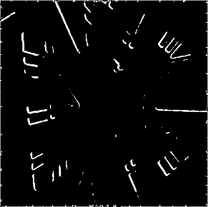

The optimal sigma depends on image factors - primarily the resolution of the image and the size of objects in it (in pixels). Filter Kernel should be big enough to cover most of the desired objects, but not so large that it starts overlapping multiple neighbouring objects at a time. Larger kernels have more values factored into the average, that blur the image more.

As shown above, if the kernel size increases more pixel getting in the consideration so smoothing and blurring pronounced, local contrast reduced so that after edge detection and threshold some edges are vanished when filter size (kernel size) increases.